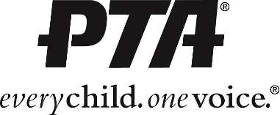

[YOUR PTA NAME] | Executive Board Agenda
[DATE] | [TIME / LOCATION]

- Call to Order
  - Roll Call and Quorum
  - President’s Welcome
- Secretary - Minutes
- Treasurer – Bank Balance & Treasurer’s Report
- Presentation of Reports
- Unfinished Business
  - [ACTION ITEMS OR ITEMS TO DISCUSS]
- New Business
- Announcements
  - [ANNOUCEMENTS IF APPLICABLE]
  - Upcoming Dates
    - [UPCOMING DATES]
- Adjourn

