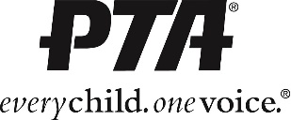
[YOUR PTA NAME]
Meeting Minutes
[DATE] | [LOCATION] | [TIME]

Call to Order
- [PRESIDENT / MEETING CHAIR] called the meeting to order at [TIME}.
- Attendance:
  - A quorum [WAS / WAS NOT] established
  - [LIST OF ATTENDEES]
Approval of Minutes
- [PRIOR MEETING DATE] Executive Board meeting minutes were approved as [WRITTEN / CORRECTED].
Treasurer’s Report
- [BEGINNING / ENDING BALANCE]
- [TOTAL EXPENSES / TOTAL INCOME]
- The Treasurer’s report was filed.
Unfinished Business
- [ANYTHING THAT HAS BEEN DISCUSSED ALREADY, AND IS BEING DISCUSSED AGAIN, OR REQUIRES FURTHER ACTION]
New Business
- [ANYTHING THAT HAS NOT BEEN BROUGHT UP FOR DISCUSSION PRIOR TO THIS MEETING]
Adjournment / Upcoming Events
- Meeting Adjourned at [TIME]
- Next meeting is at [DATE, TIME, PLACE]
- Upcoming Events
  - [LIST OF UPCOMING EVENTS]

[NAME], Recording Secretary ____________________________________
Approved: ____________ ( date) As Written Corrected (check one)

